DATA VISUALIZATION AND INSIGHT COMMUNICATION USING R
Internship Project — Week 2 Deliverable

This Photo by Unknown Author is licensed under CC BY-NC
Prepared By: Mudrika Mishra
Program: PGDM (Business Analytics)
Institution: Jaipuria Institute of Management
Internship: Virtual R Data Analyst Internship
Dataset: Reliance Industries Stock Market Data
Study Period: 6 May 2025 – 5 May 2026
Tools Used: RStudio, R, ggplot2, dplyr, readxl
GitHub Repository: Virtual R Data Analyst Internship

1. Executive Summary
This project focuses on visualizing and interpreting Reliance Industries' stock market data using R. The primary objective is to identify price trends, daily return fluctuations, trading volume patterns, and unusual observations through appropriate graphical techniques.
The dataset contains 248 observations covering the period from 6 May 2025 to 5 May 2026. The analysis uses line charts, a histogram, a scatter plot, a monthly average trend chart, and a boxplot to examine the data from different perspectives.
The highest recorded closing price was ₹1,592 on 2 January 2026, while the lowest was ₹1,305 on 7 April 2026. The difference between these closing prices was ₹287.
The average daily return was approximately 0.0174%, while the standard deviation was approximately 1.30%. The correlation between trading volume and closing price was −0.359, indicating a moderate negative linear association in the observed data.
The visualizations help communicate stock price movements, return variability, and potential outliers. These findings provide a descriptive overview of the stock's historical performance during the study period. They do not, by themselves, establish the causes of price movements or predict future performance.

2. Introduction
Data visualization is an important part of data analysis because it converts numerical information into graphical representations that are easier to understand.
Financial datasets can contain frequent fluctuations, extreme observations, and relationships between variables that may not be immediately apparent from tables alone.
In this project, R is used to visualize Reliance Industries' daily stock market data. The analysis focuses on closing prices, daily returns, trading volume, monthly average closing prices, and the distribution of returns.
The project also emphasizes insight communication. Each visualization is accompanied by an explanation of what the graph shows and why the observation may be relevant to understanding stock market behavior.

3. Objectives of the Analysis
The main objectives are:
- To examine daily closing price movements over the study period.
- To visualize daily stock returns and identify positive and negative movements.
- To understand the distribution of daily returns using a histogram.
- To examine the relationship between trading volume and closing price.
- To compare monthly average closing prices.
- To identify potential outliers in daily returns.
- To communicate the findings through clear visualizations, numerical evidence, and non-technical explanations.

4. Dataset Overview
The dataset contains daily stock market observations for Reliance Industries.

4.1 Dataset Information
Attribute | Details
Company | Reliance Industries
Total observations | 248
Starting date | 6 May 2025
Ending date | 5 May 2026
Observation frequency | Daily records in the dataset
Analysis tool | RStudio
Main visualization package | ggplot2
The 248 observations represent the records available in the dataset. They should not be interpreted as 248 calendar days because stock market data does not necessarily contain observations for weekends and market holidays.

4.2 Key Variables
Variable | Description
DATE | Date of the stock market observation
OPEN | Opening stock price
HIGH | Highest recorded price during the trading session
LOW | Lowest recorded price during the trading session
CLOSE | Closing stock price
VOLUME | Number of shares traded, as recorded in the dataset
RETURNS | Daily stock return recorded in the dataset
The CLOSE variable is used to examine price trends. RETURNS is used to understand daily gains and losses, while VOLUME is used to explore its association with the closing price.

5. Tools and Methodology
The analysis was conducted using RStudio.
The following packages and functions were used:
- readxl: To import the Excel dataset.
- dplyr: To organize data and calculate monthly averages.
- ggplot2: To create visualizations.
- Base R functions: To calculate summary statistics, identify minimum and maximum values, calculate standard deviation, and measure correlation.
The analysis followed these steps:
- Imported the stock market dataset into RStudio.
- Inspected the available columns and initial observations.
- Arranged the data in chronological order.
- Created line charts to examine time-based patterns.
- Used a histogram and boxplot to examine daily return distributions.
- Created a scatter plot to investigate the relationship between trading volume and closing price.
- Calculated monthly average closing prices.
- Calculated descriptive statistics and interpreted the findings.
The visualizations were developed to support exploratory analysis rather than to establish causal relationships or make investment recommendations.

6. Data Visualization and Interpretation

6.1 Visualization 1: Daily Closing Price Trend
Objective: To understand how Reliance Industries' closing price changed during the study period.
R Code:
library(ggplot2)

ggplot(RIL_FINAL_xlxs, aes(x = DATE, y = CLOSE)) +
geom_line() +
labs(
title = "Reliance Industries: Daily Closing Prices",
x = "Date",
y = "Closing Price (₹)"
) +
theme_minimal()

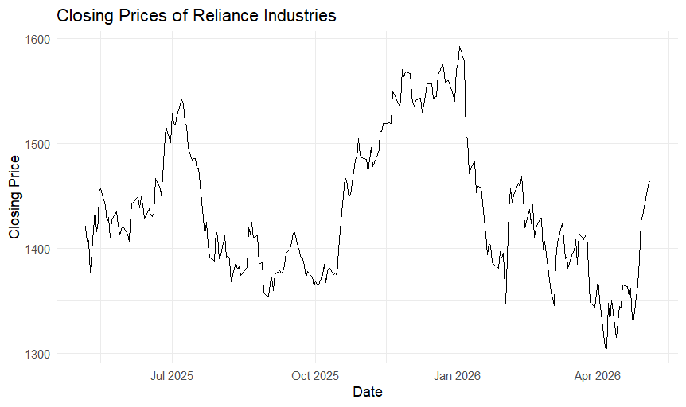
Interpretation:
The daily closing price chart shows fluctuations in Reliance Industries' stock price throughout the study period. The highest recorded closing price in the dataset was ₹1,592 on 2 January 2026, while the lowest was ₹1,305 on 7 April 2026.
The difference between these two recorded closing prices was ₹287.
The graph shows that the stock price experienced both upward and downward movements rather than following a constant trend. This visualization provides an overview of historical price movements and helps identify periods of relative increases and decreases.
Business Insight:
Monitoring closing price movements can help analysts understand historical market behaviour. However, a line chart alone cannot explain why prices changed or establish what future prices will be.

6.2 Visualization 2: Daily Returns Trend
Objective: To visualize daily positive and negative stock returns and identify periods of larger movements.
R Code:
ggplot(RIL_FINAL_xlxs, aes(x = DATE, y = RETURNS)) +
geom_line() +
labs(
title = "Daily Returns of Reliance Industries",
x = "Date",
y = "Daily Returns"
) +
theme_minimal()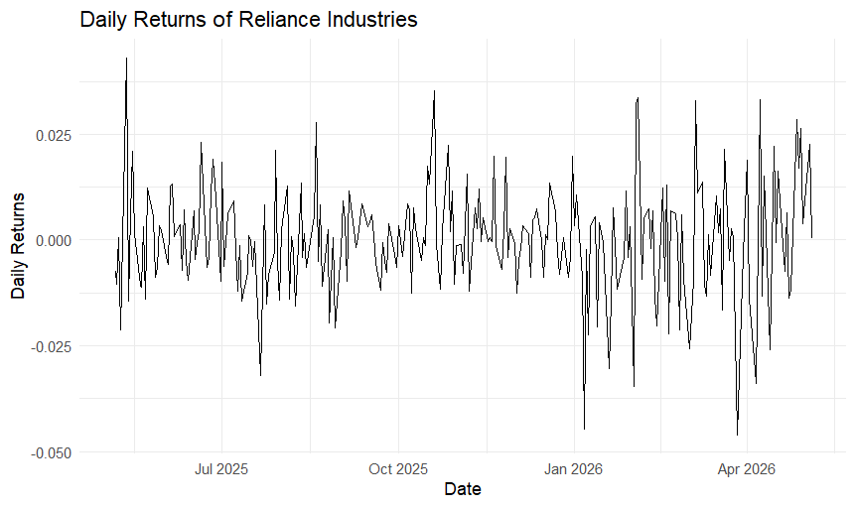

Interpretation:
The daily returns chart contains frequent upward and downward movements around the zero level. Positive returns represent positive daily performance according to the return values in the dataset, while negative returns represent negative daily performance.
The summary statistics show that the minimum recorded return was −4.60% and the maximum was +4.31%.
The visible spikes indicate that some daily returns were considerably larger or smaller than the values observed on many other days. These movements make daily returns useful for examining short-term variability.
Business Insight:
Daily returns provide a complementary perspective to closing prices. While closing prices show the price level, returns describe the direction and magnitude of daily changes.

6.3 Visualization 3: Distribution of Daily Returns Using a Histogram
Objective: To understand how frequently different daily return values occurred.
R Code:
ggplot(RIL_FINAL_xlxs, aes(x = RETURNS)) +
geom_histogram() +
labs(
title = "Distribution of Daily Returns",
x = "Daily Returns",
y = "Frequency"
) +
theme_minimal()

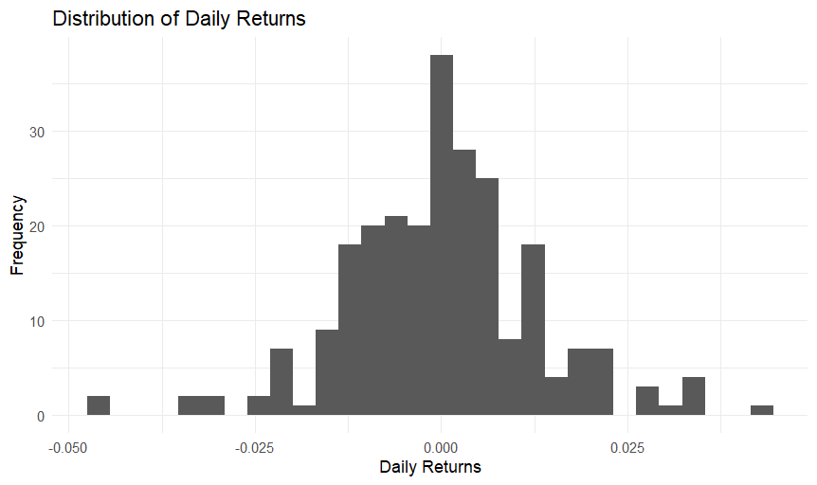
Interpretation:
The histogram groups daily returns into intervals and shows how frequently observations fall within each interval.
The descriptive statistics indicate that the mean daily return was approximately +0.0174%, while the median was +0.02%. These values are close to zero, indicating that the centre of the daily return distribution was near zero.
However, the returns were not identical across observations. The minimum return was −4.60%, and the maximum was +4.31%.
The histogram helps communicate the concentration and spread of daily returns more clearly than a list of individual observations.
Business Insight:
Understanding the distribution of returns can help analysts identify whether daily movements are generally small or whether larger movements also occur. The histogram should be interpreted together with the summary statistics and boxplot.

6.4 Visualization 4: Trading Volume versus Closing Price
Objective: To explore the relationship between trading volume and closing price.
R Code:
ggplot(RIL_FINAL_xlxs, aes(x = VOLUME, y = CLOSE)) +
geom_point() +
labs(
title = "Trading Volume versus Closing Price",
x = "Trading Volume",
y = "Closing Price (₹)"
) +
theme_minimal()

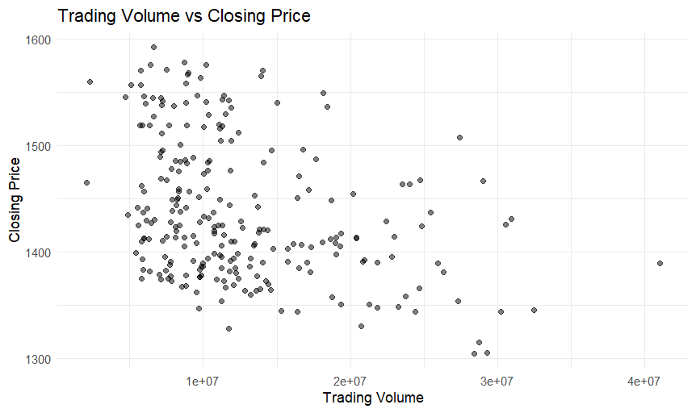

Interpretation:
The scatter plot compares trading volume with the corresponding closing price for each observation.
The points are distributed across different trading volumes and closing prices. The calculated Pearson correlation coefficient between VOLUME and CLOSE was −0.3586, approximately −0.359.
This indicates a moderate negative linear association in the observed dataset. In other words, higher trading volume tended to be associated with lower closing prices in the overall linear comparison, although individual observations may differ.
Correlation does not establish causation. This result does not prove that an increase in trading volume causes the closing price to fall.
Business Insight:
Examining trading volume alongside closing prices can provide additional context for understanding market activity. Further analysis would be required to determine whether the observed association remains after considering other factors and time-related patterns.

6.5 Visualization 5: Monthly Average Closing Price
Objective: To compare average closing prices across months and identify broader patterns.
R Code:
library(dplyr)

monthly_data <- RIL_FINAL_xlxs %>%
mutate(Month = format(DATE, "%Y-%m")) %>%
group_by(Month) %>%
summarise(
Average_Close = mean(CLOSE, na.rm = TRUE),
.groups = "drop"
)

ggplot(
monthly_data,
aes(x = Month, y = Average_Close, group = 1)
) +
geom_line() +
geom_point() +
labs(
title = "Monthly Average Closing Price of Reliance Industries",
x = "Month",
y = "Average Closing Price (₹)"
) +
theme_minimal() +
theme(
axis.text.x = element_text(angle = 45, hjust = 1)
)

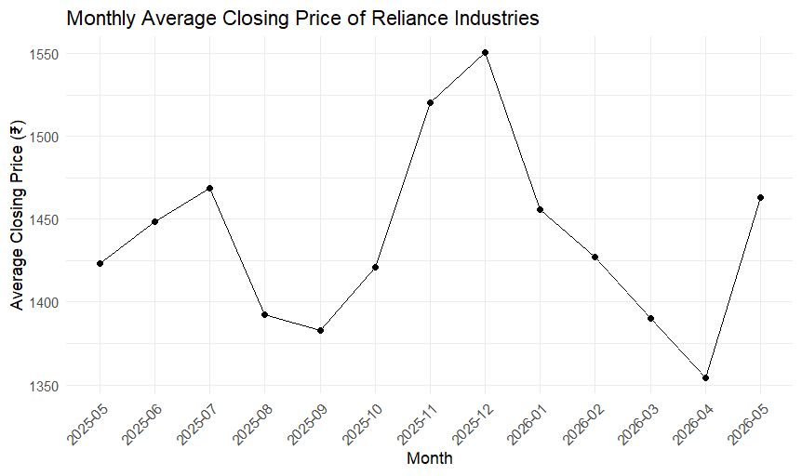
Monthly Results:
Month | Average Closing Price (approximately)
May 2025 | ₹1,423
June 2025 | ₹1,449
July 2025 | ₹1,468
August 2025 | ₹1,393
September 2025 | ₹1,383
October 2025 | ₹1,421
November 2025 | ₹1,520
December 2025 | ₹1,550
January 2026 | ₹1,456
February 2026 | ₹1,427
March 2026 | ₹1,390
April 2026 | ₹1,354
May 2026 | ₹1,463
Interpretation:
The monthly average closing price reached its highest value of approximately ₹1,550 in December 2025. The lowest monthly average was approximately ₹1,354 in April 2026.
The average price increased between May and July 2025, declined in August and September, and rose again in November and December. From January through April 2026, the monthly average generally decreased before rising again in May.
The May 2025 and May 2026 averages are based on partial months in the dataset. Therefore, comparisons involving these two months should be interpreted with this limitation in mind.
Business Insight:
Monthly averages help summarize short-term price fluctuations and communicate broader changes over time. They should be considered alongside daily data because monthly averages can hide substantial movements within individual trading sessions.

6.6 Visualization 6: Boxplot of Daily Returns
Objective: To identify the spread of daily returns and detect potential outliers.
R Code:
ggplot(RIL_FINAL_xlxs, aes(y = RETURNS)) +
geom_boxplot() +
labs(
title = "Distribution of Daily Returns",
y = "Daily Returns",
x = ""
) +
theme_minimal()

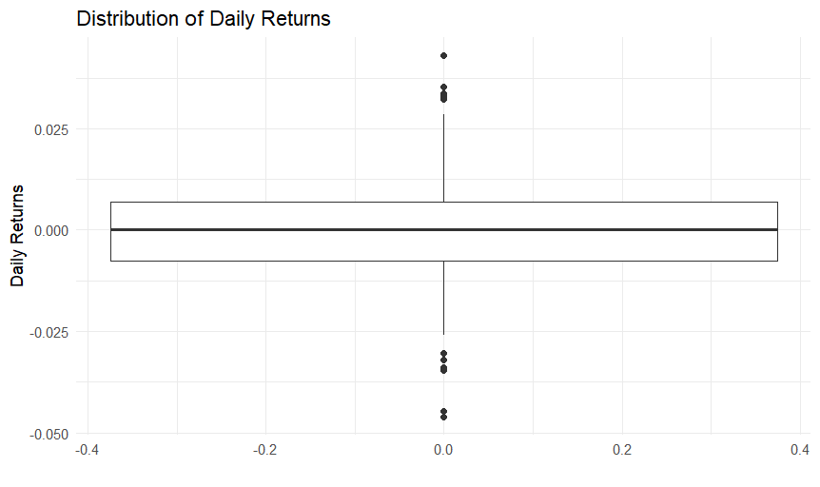
Interpretation:
The boxplot displays the central distribution of daily returns, including the median, the interquartile range, and observations beyond the whiskers.
The graph shows a small number of potential outliers. These observations represent returns that lie relatively far from the central portion of the distribution.
The descriptive statistics support the observation that daily returns varied across the study period. The minimum return was −4.60%, the maximum was +4.31%, and the standard deviation was approximately 1.30%.
Potential outliers should not automatically be removed. In financial data, extreme observations may represent genuine market movements rather than data-entry errors.
Business Insight:
Identifying unusual returns helps analysts determine which observations may require additional investigation. Further checks are necessary before classifying an observation as an error or excluding it from analysis.

6.7 Visualization 7: Additional Visualization
Objective: To communicate an additional pattern or relationship identified during the analysis.
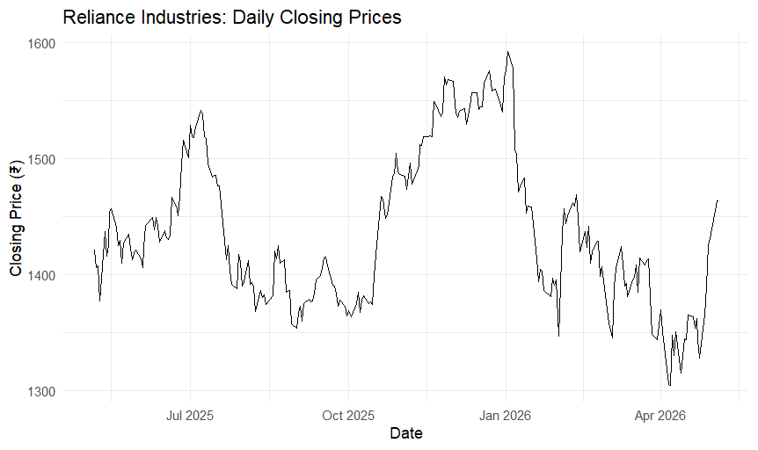
Graph Title: Daily Closing Prices
R Code:
head(RIL_FINAL_xlxs[, c("DATE", "CLOSE")])
# A tibble: 6 × 2
DATE CLOSE
<dttm> <dbl>
1 2025-05-06 00:00:00 1421.
2 2025-05-07 00:00:00 1406
3 2025-05-08 00:00:00 1407
4 2025-05-09 00:00:00 1377.
5 2025-05-12 00:00:00 1436.
6 2025-05-13 00:00:00 1416.
> ggplot(RIL_FINAL_xlxs, aes(x = DATE, y = CLOSE)) +
+ geom_line() +
+ labs(
+ title = "Reliance Industries: Daily Closing Prices",
+ x = "Date",
+ y = "Closing Price (₹)"
+ ) +
+ theme_minimal()
> RIL_FINAL_xlxs[which.max(RIL_FINAL_xlxs$CLOSE),
+ c("DATE", "CLOSE")]

Interpretation:
DATE CLOSE
<dttm> <dbl>
1 2026-01-02 00:00:00 1592.
> RIL_FINAL_xlxs[which.min(RIL_FINAL_xlxs$CLOSE),
+ c("DATE", "CLOSE")]
# A tibble: 1 × 2
DATE CLOSE
<dttm> <dbl>
1 2026-04-07 00:00:00 1305.
> nrow(RIL_FINAL_xlxs)
[1] 248
>
> range(RIL_FINAL_xlxs$DATE)
[1] "2025-05-06 UTC" "2026-05-05 UTC"
> nrow(RIL_FINAL_xlxs)
[1] 248
> library(dplyr)
Business Insight:
The monthly average closing price analysis revealed variations in Reliance Industries' stock prices during the study period. The highest monthly average closing price was ₹1,550 in December 2025, while the lowest was ₹1,354 in April 2026. The average price increased between May and July 2025, declined during August and September, and then rose in November and December. From January to April 2026, the monthly average generally decreased before increasing again in May 2026. These findings illustrate the changing price trend over the study period. Since May 2025 and May 2026 cover partial months in the dataset, their averages should be interpreted with this limitation in mind.

7. Descriptive Statistical Analysis
Descriptive statistics provide numerical evidence to support the visual findings.

7.1 Daily Returns Summary
Measure | Value
Minimum return | −0.0460
First quartile | −0.0077
Median | 0.0002
Mean | 0.0001742
Third quartile | 0.0070
Maximum return | 0.0431
Standard deviation | 0.01304393
R Code:
summary(RIL_FINAL_xlxs$RETURNS)

sd(RIL_FINAL_xlxs$RETURNS, na.rm = TRUE)
Interpretation:
The mean daily return was approximately +0.0174%, and the median was +0.02%. The minimum and maximum returns were −4.60% and +4.31%, respectively.
The first quartile was −0.77%, while the third quartile was +0.70%. This means that the middle 50% of recorded daily returns fell approximately between −0.77% and +0.70%.
The standard deviation was approximately 1.30%, indicating that daily returns exhibited variability around their average.

7.2 Highest and Lowest Closing Prices
R Code:
RIL_FINAL_xlxs[
which.max(RIL_FINAL_xlxs$CLOSE),
c("DATE", "CLOSE")
]

RIL_FINAL_xlxs[
which.min(RIL_FINAL_xlxs$CLOSE),
c("DATE", "CLOSE")
]
Results:
- Highest closing price: ₹1,592 on 2 January 2026.
- Lowest closing price: ₹1,305 on 7 April 2026.
- Difference: ₹287.
These figures identify the maximum and minimum closing prices among the available observations. They do not represent the highest and lowest intraday prices, which are recorded separately in the HIGH and LOW variables.

7.3 Correlation between Trading Volume and Closing Price
R Code:
cor(
RIL_FINAL_xlxs$VOLUME,
RIL_FINAL_xlxs$CLOSE,
use = "complete.obs"
)
Result: −0.3585515, approximately −0.359.
Interpretation:
The correlation coefficient indicates a moderate negative linear association between trading volume and closing price in this dataset. This is a descriptive result and does not demonstrate a causal relationship.

8. Overall Findings and Business Insights
The visualization and statistical analysis produced several findings:
- Closing price variation: The highest recorded closing price was ₹1,592 on 2 January 2026, and the lowest was ₹1,305 on 7 April 2026.
- Monthly price movement: December 2025 had the highest monthly average closing price, at approximately ₹1,550. April 2026 had the lowest monthly average, at approximately ₹1,354.
- Daily return fluctuations: Daily returns ranged from −4.60% to +4.31%, showing that both negative and positive daily movements occurred during the study period.
- Return variability: The standard deviation of daily returns was approximately 1.30%, indicating variation in daily performance.
- Trading volume relationship: The correlation between trading volume and closing price was approximately −0.359. This suggests a moderate negative linear association in the observed data, without establishing causation.
- Potential outliers: The boxplot showed a small number of potential outliers. These observations require investigation before any decision is made to remove or adjust them.
- Value of visualization: Combining line charts, a histogram, a scatter plot, and a boxplot made it possible to examine trends, distributions, relationships, and unusual observations from different perspectives.
Overall, the analysis demonstrates how visualization can support exploratory financial analysis and communicate numerical findings more effectively.

9. Limitations of the Analysis
The results should be interpreted in light of the following limitations:
- The dataset contains 248 observations and covers approximately one year.
- The analysis is descriptive and does not establish the causes of stock price movements.
- Correlation does not imply causation.
- Monthly averages summarise daily observations and may conceal movements within a month.
- May 2025 and May 2026 contain partial-month observations in the available dataset.
- Potential outliers have been identified visually but have not been independently verified as errors or genuine market events.
- The analysis does not provide an investment recommendation or guarantee future performance.

10. Conclusion
This project applied R-based data visualization techniques to examine Reliance Industries' stock market data over the period from 6 May 2025 to 5 May 2026.
The analysis identified a maximum closing price of ₹1,592 and a minimum closing price of ₹1,305. Monthly averages showed that December 2025 had the highest monthly average closing price, while April 2026 had the lowest. Daily returns fluctuated between −4.60% and +4.31%, with a standard deviation of approximately 1.30%.
The scatter plot identified a correlation of approximately −0.359 between trading volume and closing price, while the boxplot highlighted a small number of potential outliers requiring further investigation.
The project strengthened the use of R for visual exploration, descriptive statistics, and communicating analytical findings. It also demonstrated the importance of supporting visual observations with actual numerical results and clearly explaining the limitations of the analysis.

11. Learning Outcomes
Through this project, the following skills were practiced:
- Importing and inspecting financial data in RStudio.
- Creating line charts to analyze trends over time.
- Using histograms to examine the distribution of returns.
- Using scatter plots to explore relationships between numerical variables.
- Calculating monthly averages with dplyr.
- Calculating descriptive statistics and correlation using R.
- Identifying potential outliers using a boxplot.
- Interpreting analytical results in simple, business-oriented language.
- Communicating findings through a structured report.

12. Project Repository
GitHub Repository: Virtual R Data Analyst Internship
Repository link: https://github.com/Mudrikamishra05/Virtual-R-Data-Analyst-Internship
The repository should contain the relevant project files, including the R script or notebook used for the analysis and the report. Any dataset included in the repository should be permitted for redistribution and should not contain confidential information.

End of Week 2 Report

